Practical 9:
Aim:
Problem 1
A disaster relief team needs to inspect all buildings in a city after an earthquake. The city is
mapped as a network where buildings are connected by roads. One team starts at a building
and goes as deep into each road as possible before backtracking, while a second team spreads
out level by level — first checking all buildings directly connected to the start, then all buildings
two roads away, and so on. Given the city map as a graph and a starting building, implement
both exploration strategies and print the order in which buildings are visited by each team.
Describe how the order of buildings visited differs between the two strategies on the same
graph. What data structure does each strategy rely on to decide which building to visit next, and
how does that structure cause the difference in order?
Practical-link:
https://github.com/kahanipatel156-dev/FDSA-Batch-B/tree/main/Practical-9

Screenshots:
Problem 1:
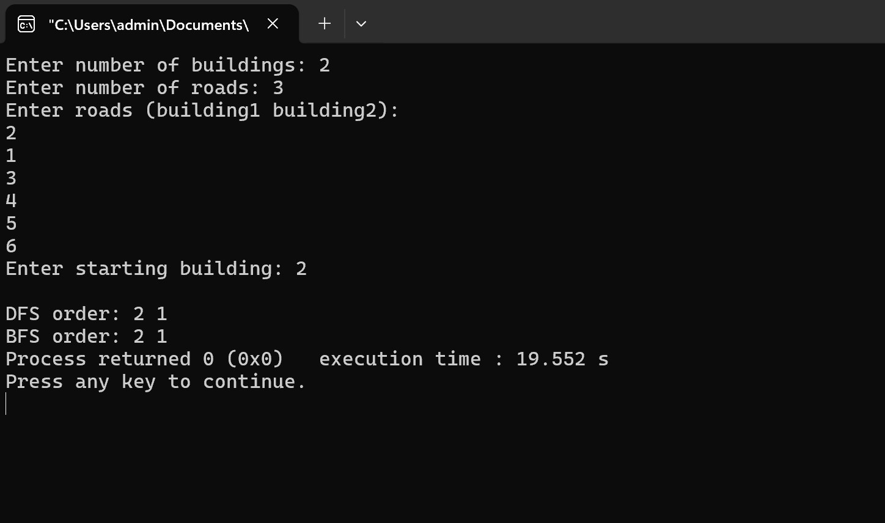
Problem-faced:
Implementation of concepts.
Learning:
Concepts of graph traversal.

